**Project Design Phase-II**

**Data Flow Diagram & User Stories**

|  |  |
| --- | --- |
| Date | 25 January 2025 |
| Team ID | SWTID1744365286 |
| Project Name | Movie Ticket Booking System |
| Maximum Marks | 4 Marks |

**Data Flow Diagrams:**

A Data Flow Diagram (DFD) is a traditional visual representation of the information flows within a system. A neat and clear DFD can depict the right amount of the system requirement graphically. It shows how data enters and leaves the system, what changes the information, and where data is stored.

Example: DFD Level 0(Industry Standard)

**Example:** [**(Simplified)**](https://developer.ibm.com/patterns/visualize-unstructured-text/)

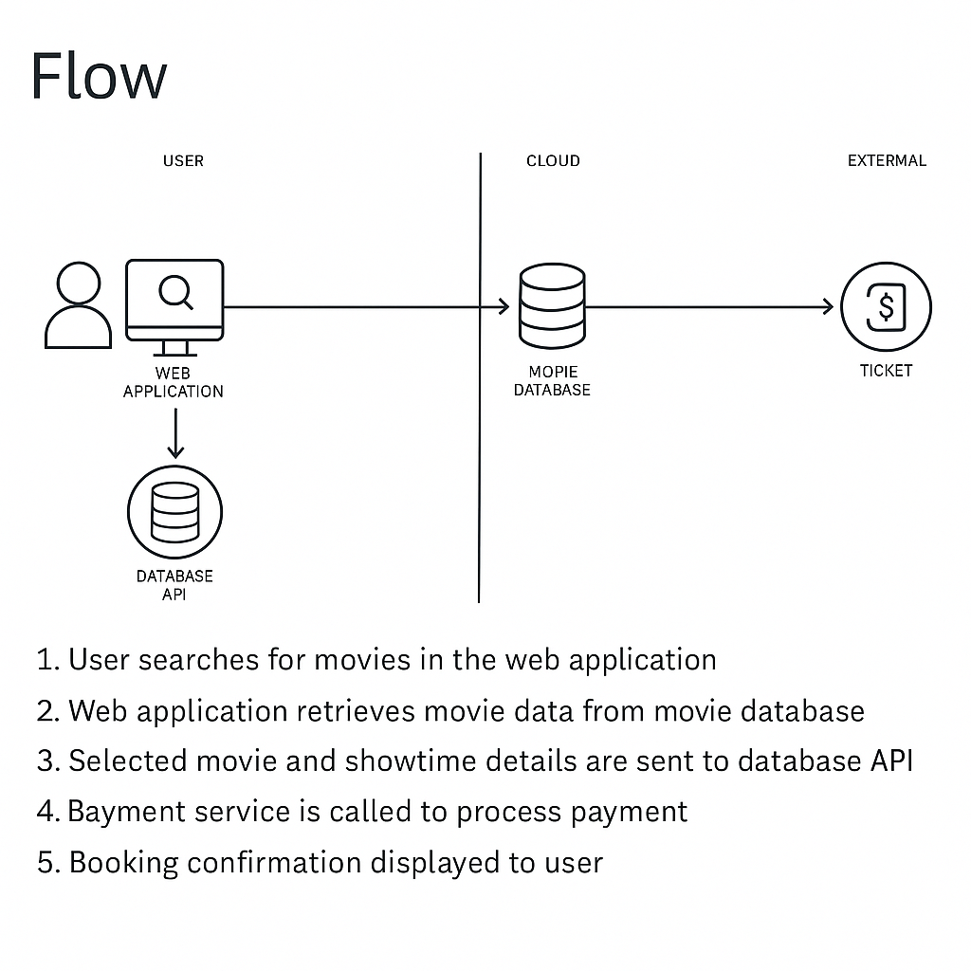

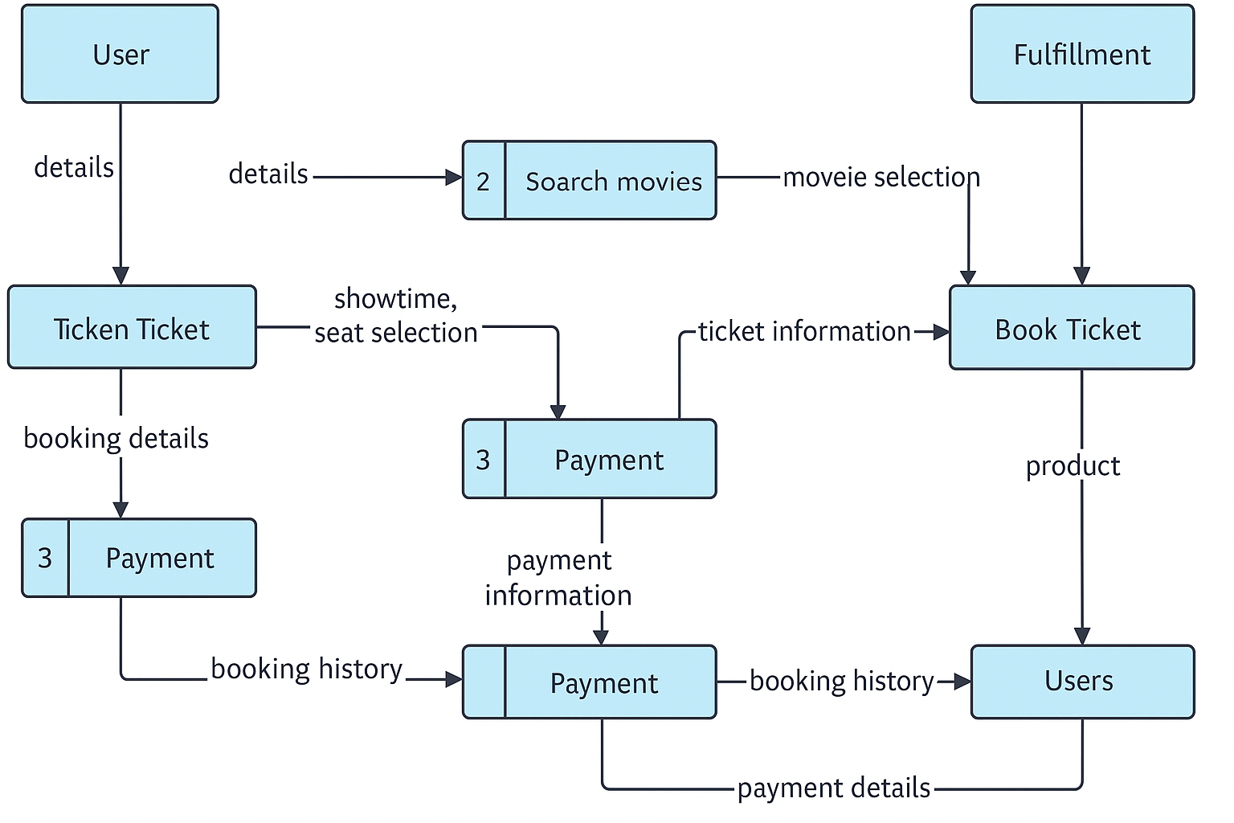

**User Stories**

Use the below template to list all the user stories for the product.

| **User Type** | **Functional Requirement (Epic)** | **User Story Number** | **User Story / Task** | **Acceptance criteria** | **Priority** | **Release** |
| --- | --- | --- | --- | --- | --- | --- |
| Customer (Mobile user) | Registration | USN-1 | As a user, I can register for the application by entering my email, password, and confirming my password. | I can access my account / dashboard | High | Sprint-1 |
|  |  | USN-2 | As a user, I will receive confirmation email once I have registered for the application | I can receive confirmation email & click confirm | High | Sprint-1 |
|  |  | USN-3 | As a user, I can register for the application through Facebook | I can register & access the dashboard with Facebook Login | Low | Sprint-2 |
|  |  | USN-4 | As a user, I can register for the application through Gmail | I can register & access the dashboard with Gmail Login. | Medium | Sprint-1 |
|  | Login | USN-5 | As a user, I can log into the application by entering email & password | I can successfully log in and access my account. | High | Sprint-1 |
|  | Search & Browse Movie | USN-6 | As a user, I can browse currently available movies by genre, language, and format (2D/3D/IMAX). | I can view and filter movies based on my preferences. | |  | | --- | | High |  |  | | --- | |  | | Sprint-1 |
|  | Seat selection | USN-7 | As a user, I can select my preferred seats before booking. | I can view the seating layout and pick available seats. | High | |  | | --- | | Sprint-1 |  |  | | --- | |  | |
|  | Payment | USN-8 | As a user, I can pay for my ticket using a credit card, debit card, UPI, or digital wallets. | |  | | --- | | I receive a successful transaction message and my ticket is booked. |  |  | | --- | |  | | |  | | --- | | High |  |  | | --- | |  | | |  | | --- | | Sprint-1 |  |  | | --- | |  | |
|  | |  | | --- | | Ticket Confirmation |  |  | | --- | |  | | USN-9 | As a user, I receive an email and SMS confirmation after booking my ticket. | |  | | --- | | I get a ticket with a QR code and details of my movie. |  |  | | --- | |  | | Medium | Sprint-2 |
| Customer (Web user) | |  | | --- | | User Support |  |  | | --- | |  | | USN-10 | |  |  |  | | --- | --- | --- | | |  | | --- | | As a web user, I can register and log in using email, Gmail, or Facebook. |  |  | | --- | |  | |  |  | | --- | |  | | |  |  |  | | --- | --- | --- | | |  | | --- | | I can access my account and book tickets. |  |  | | --- | |  | |  |  | | --- | |  | | |  | | --- | |  |   High | Sprint-1 |
| Customer Care Executive | |  | | --- | | Manage Movies & Shows |  |  | | --- | |  | | USN-11 | |  | | --- | | As an admin, I can add, update, and delete movie listings and showtimes. |  |  | | --- | |  | | |  |  |  | | --- | --- | --- | | |  | | --- | | I can see my ticket history and upcoming shows. |  |  | | --- | |  | |  |  | | --- | |  | | |  | | --- | |  |   Medium | Sprint-2 |
| Administrator |  | USN-12 | |  | | --- | | As a support agent, I can view user details and assist with booking issues. |  |  | | --- | |  | | |  | | --- | | I can resolve user issues and update their booking status. |  |  | | --- | |  | | Medium | Sprint-2 |